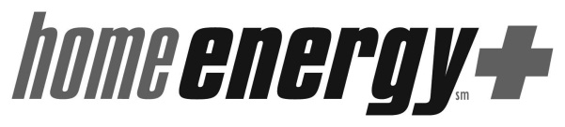
HE+ Furnace Program Customer Agreement
 | Weatherization Agency |  | Customer |  | Furnace Contractor
Name |  | Name |  | Name
Phone |  | Phone |  | Phone

Please check the appropriate response(s), sign and date this form.
I consent to a heating system replacement. I understand I will be required to surrender my old heating system and allow a Furnace Program staff member to enter my home for a final safety and performance inspection within 2 weeks of installation, or future HE+ Furnace Program services may be denied. If further furnace work is required to comply with safety standards and performance specifications, I agree to allow the contractor to perform the work and a follow-up inspection to take place.
I understand that randomly selected customers will also receive a Quality Assurance inspection conducted by the State of Wisconsin, Department of Administration and/or its designated subcontractor. If I am randomly selected, I agree to allow a Quality Assurance inspector to enter my home to conduct the inspection. I understand that this is in addition to the final safety and performance inspection.
By accepting this heating system replacement, I further agree to properly maintain the unit as described in the owner’s manual. I understand that if maintenance is neglected then future HE+ Furnace Program services may be denied.
I understand the Home Energy Plus Furnace Program does not service air conditioners and is not liable for future maintenance and/or operation of air conditioning units.

I decline the heating system replacement. (*Please indicate why.)
________________________________________________________________________________________
________________________________________________________________________________________

Customer Signature: _________________________________________________ Date: _____________
Printed Name:

Contractor Signature: _________________________________________________ Date: _______________
Printed Name:

