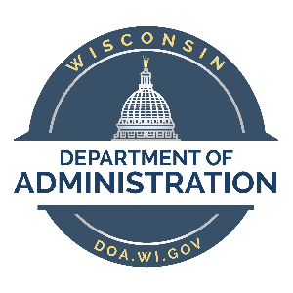

State of Wisconsin Department of Administration
Tony Evers, Governor
Kathy Blumenfeld, Secretary
David Pawlisch, Division Administrator

CHDO Certification Application

Thank you for your interest in the Community Housing Development Organization (CHDO) Program for the State of Wisconsin.
If you are applying to receive HOME funding as a CHDO under the Homebuyer and Homeowner Rehabilitation (HHR) program, please complete the entire application with the required documentation and submit it to the State along with your project information for funds. We will process your application once your packet is complete and will notify you within 60 days of approval/denial of CHDO status.
Certification applications must be submitted to the State each time the non-profit applies for HOME funds as a CHDO project. The CHDO certification and project underwriting/subsidy and layering must be approved prior to receiving the signed contract.

Contact Information
All application and initial project information should be sent to the Homebuyer and Homeowner Rehabilitation (HHR) program, at:
DOADOHHHRHCRI@wisconsin.gov.

For more information on the Federal requirements for CHDO certification and development requirements, see the Final HOME Rule, 2013, at: https://www.hudexchange.info/programs/home/home-final-rule/ and HUD CFR 92.300.

____________________________________________________________________________________________
Division of Energy, Housing and Community Resources, PO Box 7970, Madison, WI 53707-7970
Phone: 608.266.8234 DOA.WI.GOV

