Income Survey Letters & Survey Forms – Templates & Examples

From Appendix B of the CDBG Income Survey Guide
on DEHCR Bureau of Community Development – Community Resources website (under “General Resources”)
Access Additional Income Survey Letter and Survey Form Templates on the
HUD INCOME SURVEY TOOKLIT website at:
https://www.hudexchange.info/programs/cdbg/cdbg-income-survey-toolkit/

Where HUD guidance materials and Wisconsin’s State CDBG guidance materials for income surveys differ, the State guidance must be followed.

Income Survey Announcement Letter Template

[This letter is optional. An announcement letter is recommended but not required.
Delete “template” language/notes within the document and headers and footers when customizing it for use.]

[Municipality Letterhead]

<Date> [Guidance Note: This is recommended to send 2-4 weeks prior to starting the survey distribution.]

<Resident Full Name>
<Resident Full Address>

RE: Community Income Survey for Grant Application - <Optional: Add Project Focus, e.g., “Water and Sanitary Sewer Main Upgrades and Street Reconstruction on Wisconsin Street”>
Residents of: <Project Area Street(s) Names, Neighborhood Name, or Municipality Name if Community-Wide>

Dear Resident:

The <Municipality Name, e.g., Village of Yourville > plans to apply for a grant to help fund <Project Focus, e.g., “water and sanitary sewer main upgrades and street reconstruction on Wisconsin Street”; or General Purpose, e.g., “future community improvements.”> A grant can help reduce the burden of the costs at the local level for the project. To determine whether we are eligible to apply for the grant, we need to conduct a survey of Village residents to obtain family income and demographic information.

Each family living in the area where we will be making the improvements is asked to complete a survey. Your participation is voluntary and very important. We are required to get responses from a high percentage of families for the survey results to be valid and qualify us for grant eligibility.

You will soon receive the survey <Insert method, e.g., “in the mail”>. Please complete and return your survey by <Date> following the instructions that will be provided with the survey form. If you have more than one family in your household, you may contact <Contact Name>, <Contact Title>, at <Contact Information (Mailing Address, Phone, and/or Email Address)>, to request additional copies of the survey.

The responses to individual surveys will be kept confidential. If you have any questions, please contact <Contact Name>, <Contact Title>, at <Contact Information (Mailing Address, Phone, and/or Email Address)>.

Thank you for your assistance with this important survey.

Sincerely,

[Have Chief Elected Official (CEO) or Municipal Administrator Sign here.]

<CEO or Municipal Administrator Full Name>, <CEO or Municipal Administrator Title>
<Municipality Name>

Income Survey Announcement Letter Example

VILLAGE OF YOURVILLE
100 Main Street
P.O. Box 100
Yourville, WI 11111
Ph: (920) 111-2222
clerk@yourville.wi.us.gov

September 11, 2023

Sam White or Current Resident
100 First Avenue
Yourville, WI 53500

RE: Community Income Survey for Grant Application – Water and Sanitary Sewer Main Upgrades and Street Reconstruction
Residents of: Wisconsin Street, First Avenue, Brown Street, and Green Street

Dear Community Resident:

The Village of Yourville plans to apply for a grant to help fund water and sanitary sewer main upgrades and street reconstruction on Wisconsin Street, First Avenue, Brown Street, and Green Street. A grant can help reduce the burden of the costs at the local level for the project. A grant can help reduce the burden of the costs at the local level for the project. To determine whether we are eligible to apply for the grant, we need to conduct a survey of Village residents to obtain family income and demographic information.

Each family living in the area where we will be making the improvements is asked to complete a survey. Your participation is voluntary and very important. We are required to get responses from a high percentage of families for the survey results to be valid and qualify us for grant eligibility.

You will soon receive the survey in the mail. Please complete and return your survey by Friday, October 20, 2023 following the instructions that will be provided with the survey form. If you have more than one family in your household, you may contact John Doe, Community Development Specialist at XYZ Consulting, Inc., at (608) 555-1234 or jsmith@XYZConsulting.com, to request additional copies of the survey.

The responses to individual surveys will be kept confidential. If you have any questions, please contact John Doe at the contact information above or Chris Miller, Village Clerk, at (920) 111-2222 or clerk@yourville.wi.us.gov.

Thank you for your assistance with this important survey.

Sincerely,

Jane Doe

Jane Doe, Village President
Village of Yourville

Income Survey Letter Template

[Municipality Letterhead]
[Delete “template” language/notes within the document and headers and footers when customizing it for use.]

<Date>

<Addressee Name and/or Family Name and/or “Current Resident”>
<Street Address1>
<Street Address2 or P.O. Box Address>
<City, State Zip Address>

Dear <Addressee/Family Name and/or “Current Resident” or “Community Resident”>:

The <Municipality Name, e.g., Village of Yourville> is surveying our residents to see if we are eligible to apply for grant funding that requires providing income and demographic information for families in our community. This is to help fund <Add brief description of project, if the survey is for a specific project (e.g., “to make water and sanitary sewer infrastructure improvements on Madison Street” or “to build a new library”, etc.), or add a general statement (e.g., “for community improvements in the future”) if the survey is not project-specific. The project area must be identified if the property address is not listed above so the property owner knows which property to which this correspondence pertains if they own multiple properties.>. Your participation in this survey is voluntary and very important because we need a high number of responses to the survey for the results to be valid and qualify us to apply for the grant.

Please fill out and return the survey enclosed <If an online survey option is available, add instructions for this, such as: “or complete the survey online by clicking the link or scanning the QR code on the survey form enclosed.”]>. Each family living in the household is to complete a separate survey. If more than one family lives in your household, <Add instructions – example shown here and in the “Example” letter on the next page: “then contact <Contact Name, Title, Department/Firm> at <Contact Phone Number and/or Email Address>”> to request additional copies of the survey. Please return this survey by <Due Date> by <Add instructions for returning survey [e.g., scanning the QR code or using an internet link to complete and submit the survey online (emphasize a separate survey number is needed for each survey/each family; or returning the survey using the postage paid envelope provided; and/or listing any other method/option, such as dropping it off at the municipal building]>. Survey data will be collected and compiled by <Contracted Firm/Organization Name> or “the <Municipal Employee Title, e.g., Village Clerk> of <Municipality Name>”. Survey results will be tabulated in summary form for <Municipality Type> officials. Individual responses will be kept confidential.

Thank you for your consideration. We hope you will complete and return the survey to help us qualify for grant funding for the <Add short project title, if the survey is for a specific project (e.g., “Madison Street improvements,” or “community library,” or “utility and street improvements in your neighborhood,” etc., or add a general statement (e.g., “for future community improvements”>.

Sincerely,

[Have Chief Elected Official (CEO) or Municipal Administrator Sign here.]

<CEO or Municipal Administrator Full Name>, <CEO or Municipal Administrator Title>
<Municipality Name>

Enclosure: Community Survey Form

Income Survey Letter Example

VILLAGE OF YOURVILLE
100 Main Street
P.O. Box 100
Yourville, WI 11111
Ph: (920) 111-2222
clerk@yourville.wi.us.gov

October 2, 2023

Jane Smith and Family or Current Resident
12345 Main Street, Apartment #1
PO Box 500
Yourville, WI 11112

Dear Jane Smith and Family or Current Resident:

The Village of Yourville is surveying our community residents to see if we are eligible to apply for grant funding that requires providing income and demographic information for families in our community. This is to help fund water and sanitary sewer main upgrades and roadway improvements on Wisconsin Street, First Avenue, Brown Street, and Green Street. Your participation in this survey is voluntary and very important because we need a high number of responses to the survey for the results to be valid and qualify us to apply for the grant.

Please fill out and return the survey form enclosed, or click the website link or scan the QR code provided at the top of the survey form to fill out the survey online. Each family living in the household is to complete a separate survey. If more than one family lives in your household, follow the instructions on the survey form for obtaining additional survey forms or for entering individual survey numbers on the online survey form. Please return the survey no later than Friday, October 20, 2023, completing it online, mailing the completed survey form back using the postage paid envelope provided, or dropping it off at the Village Hall at 100 Main Street, Yourville, Wisconsin, between 9:00 a.m. – 4:00 p.m., Monday through Friday. Survey responses will be collected and compiled by XYZ Consulting, Inc. Survey results will be tabulated in summary form for Village officials. Individual responses will be kept confidential.

Thank you for your consideration. We hope you will complete and return the survey to help us qualify for grant funding for utility and street improvements in your neighborhood.

Sincerely,

Jane Doe

Jane Doe, Village President
Village of Yourville

Enclosure: Community Survey Form

Income Survey Form Template (Paper Survey)
[Survey must have a unique survey number assigned. Responses are to be kept confidential but cannot be anonymous. Delete “template” language/notes within the document and headers and footers when customizing it for use.]

<Municipality Name> Income Survey Survey #<Add Survey #>
INSTRUCTIONS: Please complete this survey form and return it by <Add instructions for options for returning the survey, such as: by mailing it back in the postage paid envelope provided; or dropping it off at (Add drop-off location and office hours, if applicable); or going to (Add website address for survey form, if applicable) or scanning the QR code provided (on the right) to complete the survey online (if applicable)>. <Include only if applicable: If completing the survey online, the survey number (#) that appears above must be entered for your response to be valid.>

<ADD QR
CODE
HERE, IF APPLICABLE>

If more than one family lives in your household, please have each family fill out a separate survey. Please contact <Add contact information, e.g., name, position title, organization name, phone number, and/or email address> to request additional copies of the survey form. Each must have a unique survey number. <Include only if applicable: If completing the survey online, have each family in the household enter the survey number (#) above, and then add an individual family number of “F1” for family #1 in the household, “F2” for family #2 in the household, “F3” for family #3 in the household, etc. For example, these would be the survey numbers to use for Survey #100 with 3 families living in the household: 100-F1, 100-F2, and 100-F3.>
Q1. How many people live in your household at this address?
Please include yourself and all adults and children who live in or intend to live in
the household more than 2 months during the year.
Do not include people living in separate housing units on the property.
Q2. How many of the people in your household are members of your family?
This is your “Family Size.” The definition of family for this survey is:
“people related by blood, marriage, or adoption.”
Q3. How many of your family members living in your household are in each race/ethnicity category below?
Race Category: | Enter Number (#) in Family who are in the Race Category shown on the left: | Enter Number (#) in Family who are in the Race Category on the left and also Hispanic:
White
Black/African American
Asian
American Indian/Alaskan Native
Native Hawaiian/Other Pacific Islander
Asian & White
Black/African American & White
American Indian/ Alaskan Native & Black/African American
Other Multi-Racial
Prefer Not to Answer
(Survey continued on reverse side)

Page 1 of 2
Q4. What is the total annual income of all of your family
$
members combined?
If you prefer not to give your specific income, then go to Q5.
Please only include the total income added together for yourself and your adult family members (age 18 and older) living in the household. Do not include the income of people in other families in the household.
Each family member’s income is either their Adjusted Gross Income (AGI) on their tax return for [enter most recent calendar year, e.g., 2022] (if they filed taxes) or their total income before taxes (if they did not file a tax return for [enter most recent calendar year, e.g., 2022]).
Income before taxes is money received from all earnings (wages, salary, tips, bonuses, commissions), interest, dividends, child support, alimony, welfare, social security, disability, unemployment, retirement payments, net income from businesses activities, farms, rents, royalties, trusts, estates, and any other income received regularly.
Q5. Respond here only if you did not provide your family’s total income in Q4. above.
Please find your family size (the number you entered in Q2.) in column A. Family Size. Then in the same row as your Family Size, in column C. Family Income, check “At or Below” if your family income (for adult family members age 18 and older living in your household) is the same as or less than the amount shown in column B. Income Level for your family size, or check “Above” if your family income is greater than the income level shown for your family size.
A. FAMILY SIZE: | B. INCOME LEVEL: | C. FAMILY INCOME (CHECK ONE):  Is your family income “At or Below” or “Above” the amount shown in column B. Income Level for your family size?:
Family of 1 | $<Add CDBG Income Level> | ☐ At or Below or ☐ Above
Family of 2 | $<Add CDBG Income Level> | ☐ At or Below or ☐ Above
Family of 3 | $<Add CDBG Income Level> | ☐ At or Below or ☐ Above
Family of 4 | $<Add CDBG Income Level> | ☐ At or Below or ☐ Above
Family of 5 | $<Add CDBG Income Level> | ☐ At or Below or ☐ Above
Family of 6 | $<Add CDBG Income Level> | ☐ At or Below or ☐ Above
Family of 7 | $<Add CDBG Income Level> | ☐ At or Below or ☐ Above
Family of 8 | $<Add CDBG Income Level> | ☐ At or Below or ☐ Above
Family of 9 | $<Add CDBG Income Level> | ☐ At or Below or ☐ Above
Family of 10 | $<Add CDBG Income Level> | ☐ At or Below or ☐ Above
Family of 11 | $<Add CDBG Income Level> | ☐ At or Below or ☐ Above
Family of 12 or More | $<Add CDBG Income Level> | ☐ At or Below or ☐ Above
If you have more than 12 family members living in your household, please either fill in
your family income in Q5 or respond to the Family of 12 or More option in the table above.
Q6. Please share your phone number below if we may contact you with questions about your survey responses if needed. We will not use your number for any other purpose.
( )
Phone # (with Area Code):
<Add Brief Instructions for Survey Return (Repeated) and Due Date

Page 2 of 2

Income Survey Form Example (Paper Survey)

Village of Yourville Income Survey Survey #123
INSTRUCTIONS: Please complete this survey form and return it no later than Friday, October 20, 2023 by mailing it back in the postage paid envelope provided; or dropping it off at the Village Hall at 100 Main Street, Yourville, WI during office hours (Monday – Friday, 9:00 a.m. – 4:00 p.m.); or going to www.villageofyourville.gov/community/survey or scanning the QR code provided on this form (on the right) to complete the survey online. If completing the survey online, the Survey # that appears above must be entered for your response to be valid.

If more than one family lives in your household, please have each family fill out a separate survey. Please contact John Smith of ABCD Consulting, Inc. at jsmith@ABCDConsulting.com or (608) 555-1234 to request additional copies of the survey form. Each must have a unique survey number. If completing the survey online, have each family in the household enter the survey number (#) above, and then add an individual family number of “F1” for family #1 in the household, “F2” for family #2 in the household, “F3” for family #3 in the household, etc.. For example, these would be the survey numbers to use for Survey #100 with 3 families living in the household: 100-F1, 100-F2, and 100-F3.
Q1. How many people live in your household at this address?
Please include yourself and all adults and children who live in or intend to live in
the household more than 2 months during the year.
Do not include people living in separate housing units on the property.
Q2. How many of the people in your household are members of your family?
This is your “Family Size.” The definition of family for this survey is:
“people related by blood, marriage, or adoption.”
Q3. How many of your family members are in each race/ethnicity category below?
Race Category: | Enter Number (#) in Family who are in the Race Category shown on the left: | Enter Number (#) in Family who are in the Race Category on the left and also Hispanic:
White
Black/African American
Asian
American Indian/Alaskan Native
Native Hawaiian/Other Pacific Islander
Asian & White
Black/African American & White
American Indian/ Alaskan Native & Black/African American
Other Multi-Racial
Prefer Not to Answer
(Survey continued on reverse side)

Page 1 of 2
Q4. What is the total annual income of all of your family
$
members combined?
If you prefer not to give your specific income, then go to Q5.
Please only include the total income added together for yourself and your adult family members (age 18 and older) living in the household. Do not include the income of people in other families in the household.
Each family member’s income is either their Adjusted Gross Income (AGI) on their tax return for 2022 (if they filed taxes) or their total income before taxes (if they did not file a tax return for 2022).
Income before taxes is money received from all earnings (wages, salary, tips, bonuses, commissions), interest, dividends, child support, alimony, welfare, social security, disability, unemployment, retirement payments, net income from businesses activities, farms, rents, royalties, trusts, estates, and any other income received regularly.
Q5. Respond here only if you did not provide your family’s total income in Q4. above:
Please find your family size (the number you entered in Q2.) in column A. Family Size. Then in column C. Income Level, check “At or Below” if your family income (for adult family members age 18 and older living in your household) is the same as or less than the amount shown in column B. Income Level for your family size, or check “Above” if your family income is greater than the income level shown for your family size.
A. FAMILY  SIZE: | B. INCOME LEVEL: | C. FAMILY INCOME (CHECK ONE):  Is your family income “At or Below” or “Above” the Income Level listed for your Family Size?:
Family of 1 | $48,650 | ☐ At or Below or ☐ Above
Family of 2 | $55,600 | ☐ At or Below or ☐ Above
Family of 3 | $62,550 | ☐ At or Below or ☐ Above
Family of 4 | $69,500 | ☐ At or Below or ☐ Above
Family of 5 | $75,100 | ☐ At or Below or ☐ Above
Family of 6 | $80,650 | ☐ At or Below or ☐ Above
Family of 7 | $86,200 | ☐ At or Below or ☐ Above
Family of 8 | $91,750 | ☐ At or Below or ☐ Above
Family of 9 | $97,310 | ☐ At or Below or ☐ Above
Family of 10 | $102,870 | ☐ At or Below or ☐ Above
Family of 11 | $108,430 | ☐ At or Below or ☐ Above
Family of 12 or More | $113,990 | ☐ At or Below or ☐ Above
If you have more than 12 family members living in your household, please either fill in
your family income in Q4. or respond to the Family of 12 or More option in the table above.
Q6. Please share your phone number below if we may contact you with questions about your survey responses if needed. We will not use your number for any other purpose.
( )
Phone # (with Area Code):

Please return your completed survey form in the postage paid envelope provided, drop it off at the Village Hall, or complete the survey online no later than Friday, 10/20/2023.

Page 2 of 2

Income Survey Form Template (Online Survey – Using Microsoft Forms)

[Guidance Note: The online survey must have a tracking mechanism to trace it back to the assigned survey number and residential address to verify the respondent is in the survey area and the response is not a duplicate.
Survey responses are to be kept confidential but cannot be anonymous.
If using the survey number to trace the online responses and a respondent enters an incorrect survey number in the online survey form, then the survey response may be deemed invalid
(if the response cannot be traced to the correct survey number address).
Contact DEHCR at DOACDBG@Wisconsin.gov to request additional guidance on creating an online survey form and duplicating this Microsoft Forms template that follows.]

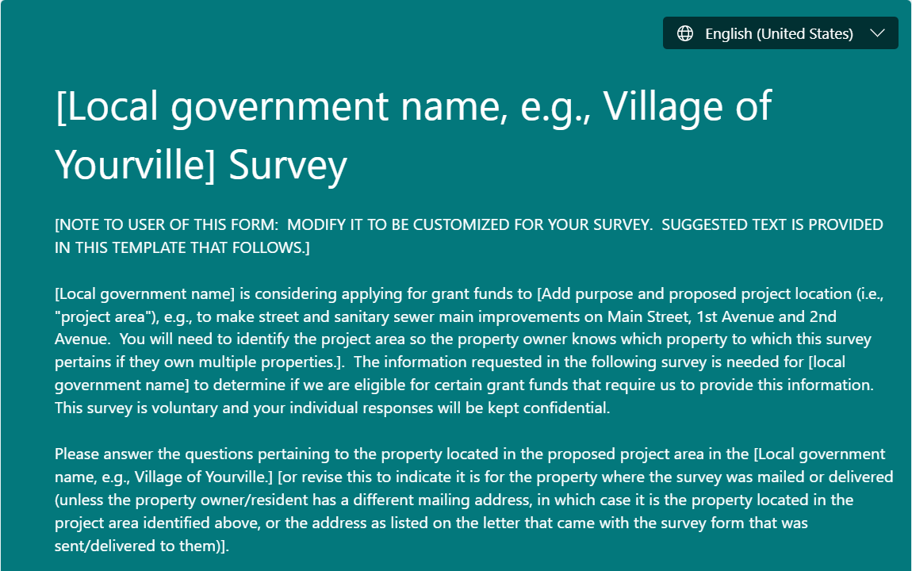

[Local government name, e.g., Village of Yourville] Survey

[NOTE TO USER OF THIS FORM: MODIFY IT TO BE CUSTOMIZED FOR YOUR SURVEY. SUGGESTED TEXT IS PROVIDED IN THIS TEMPLATE THAT FOLLOWS.]
[Local government name] is considering applying for grant funds to [Add purpose and proposed project location (i.e., "project area"), e.g., to make street and sanitary sewer main improvements on Main Street, 1st Avenue and 2nd Avenue. You will need to identify the project area so the property owner knows which property to which this survey pertains if they own multiple properties.]. The information requested in the following survey is needed for [local government name] to determine if we are eligible for certain grant funds that require us to provide this information. This survey is voluntary and your individual responses will be kept confidential.
Please answer the questions pertaining to the property located in the proposed project area in the [Local government name, e.g., Village of Yourville.] [or revise this to indicate it is for the property where the survey was mailed or delivered (unless the property owner/resident has a different mailing address, in which case it is the property located in the project area identified above, or the address as listed on the letter that came with the survey form that was sent/delivered to them)].
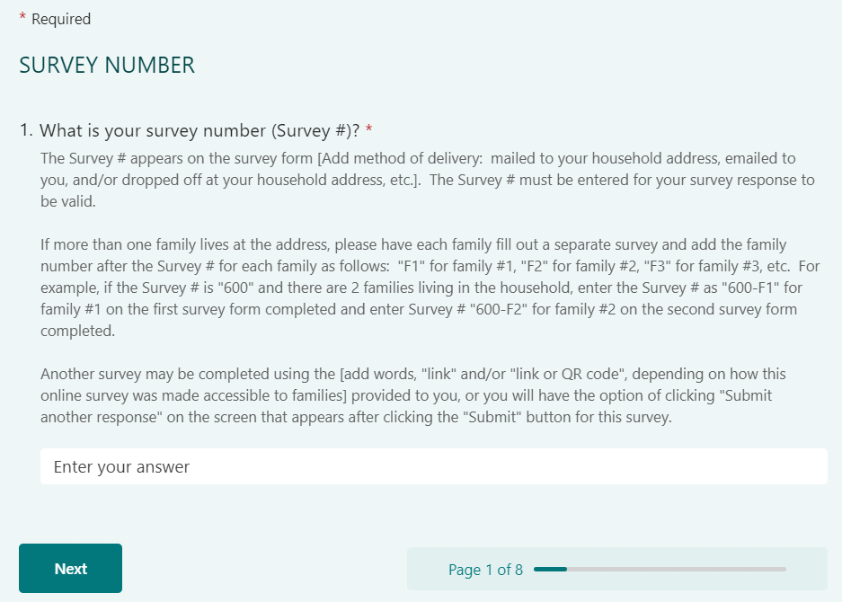

Q1. What is your survey number (Survey #)?

The Survey # appears on the survey form [Add method of delivery: mailed to your household address, emailed to you, and/or dropped off at your household address, etc.]. The Survey # must be entered for your survey response to be valid.
If more than one family lives at the address, please have each family fill out a separate survey and add the family number after the Survey # for each family as follows: "F1" for family #1, "F2" for family #2, "F3" for family #3, etc. For example, if the Survey # is "600" and there are 2 families living in the household, enter the Survey # as "600-F1" for family #1 on the first survey form completed and enter Survey # "600-F2" for family #2 on the second survey form completed.
Another survey may be completed using the [add words, "link" and/or "link or QR code", depending on how this online survey was made accessible to families] provided to you, or you will have the option of clicking "Submit another response" on the screen that appears after clicking the "Submit" button for this survey.

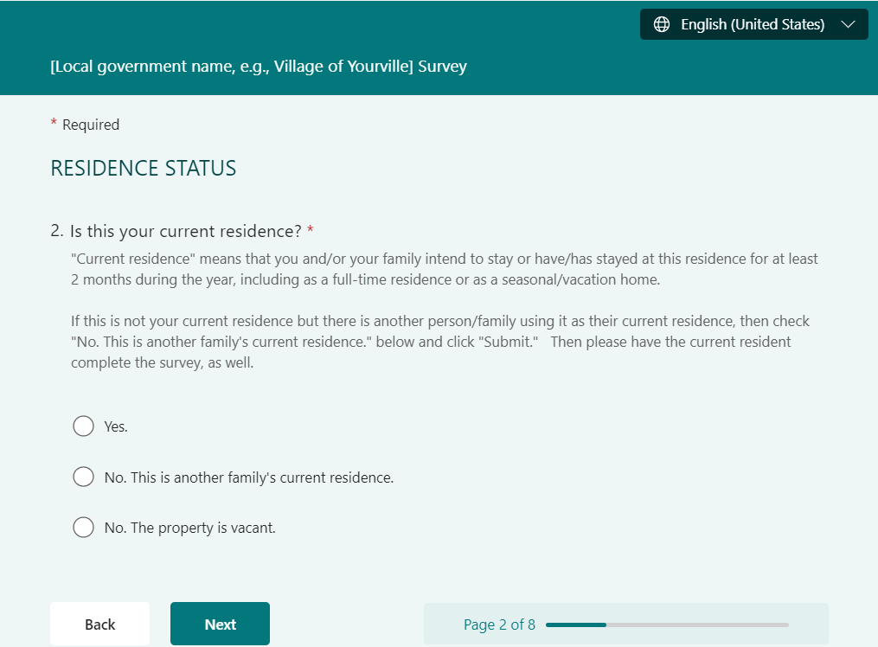

Q2. Is this your current residence?

"Current residence" means that you and/or your family intend to stay or have/has stayed at this residence for at least 2 months during the year, including as a full-time residence or as a seasonal/vacation home.
If this is not your current residence but there is another person/family using it as their current residence, then check "No. This is another family's current residence." below and click "Submit." Then please have the current resident complete the survey, as well.

- Yes.
- No. This is another family's current residence.
- No. The property is vacant.

Branching/Logic Set-Up for Next Screen:
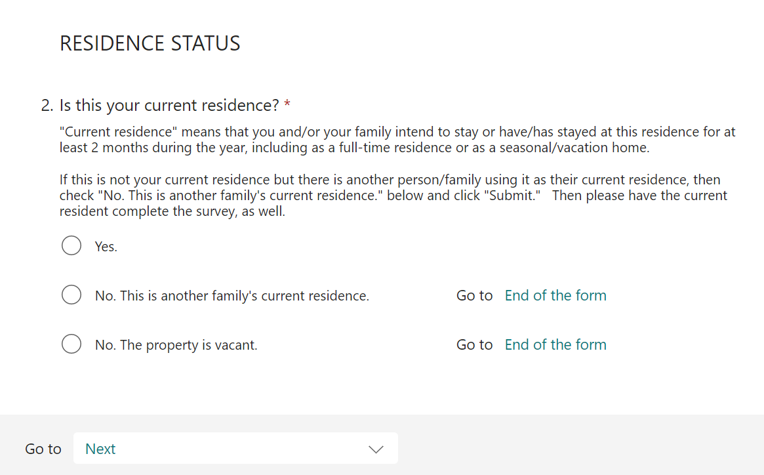

- If the “Yes” response is selected, then the “All Families Living in the Household” question will appear next.
- If either “No” option is selected, then the final survey “Thank You” screen at the end of the survey will appear next.
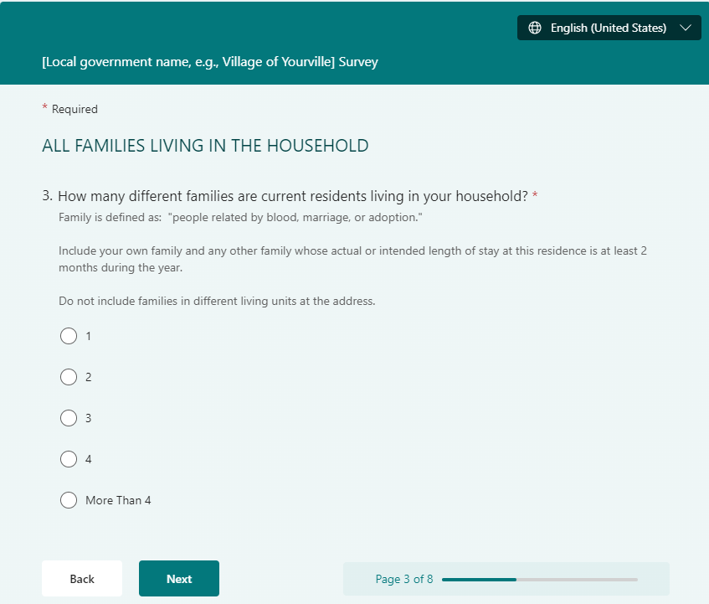

ALL FAMILIES LIVING IN THE HOUSEHOLD

Q3. How many different families are current residents living in your household?

Family is defined as: "people related by blood, marriage, or adoption."
Include your own family and any other family whose actual or intended length of stay at this residence is at least 2 months during the year.
Do not include families in different living units at the address.

- 1
- 2
- 3
- 4
- More Than 4

Branching/Logic Set-Up For Next Question:
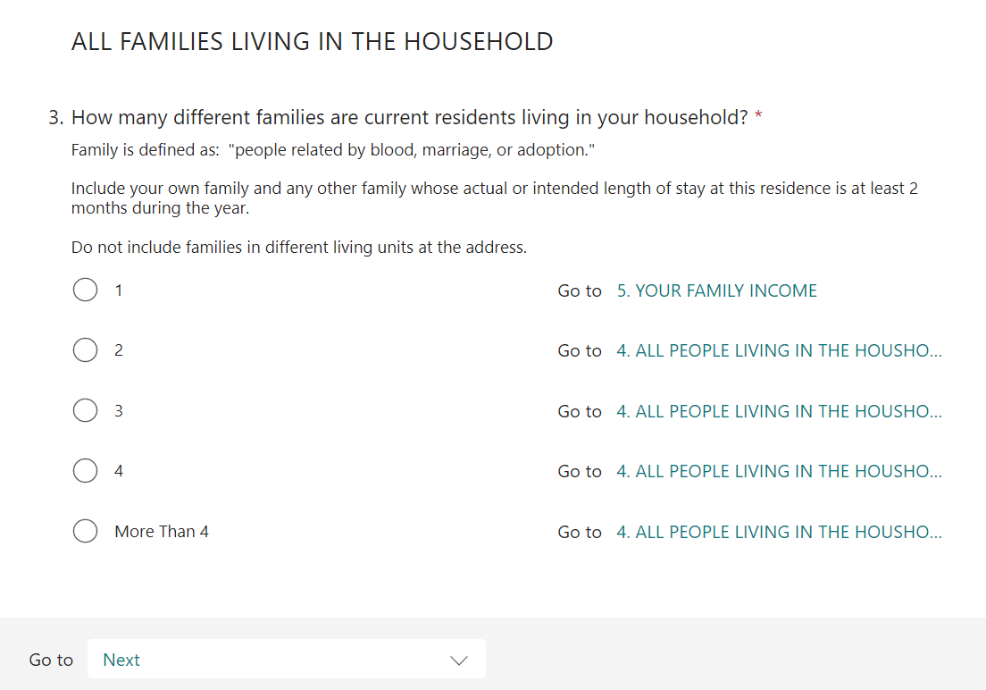

- If only 1 family lives in the household, then “Your Family Income” question will appear next.
- If 2 or more families live in the household, then the “All People Living in the Household” (# of all persons in the household) question will appear next.

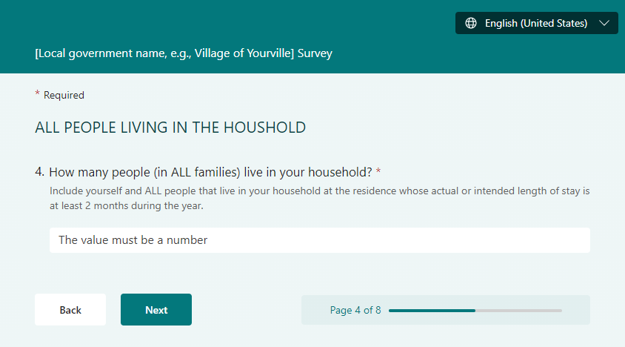

ALL PEOPLE LIVING IN THE HOUSHOLD

Q4. How many people (in ALL families) live in your household?

Include yourself and ALL people that live in your household at the residence whose actual or intended length of stay is at least 2 months during the year.

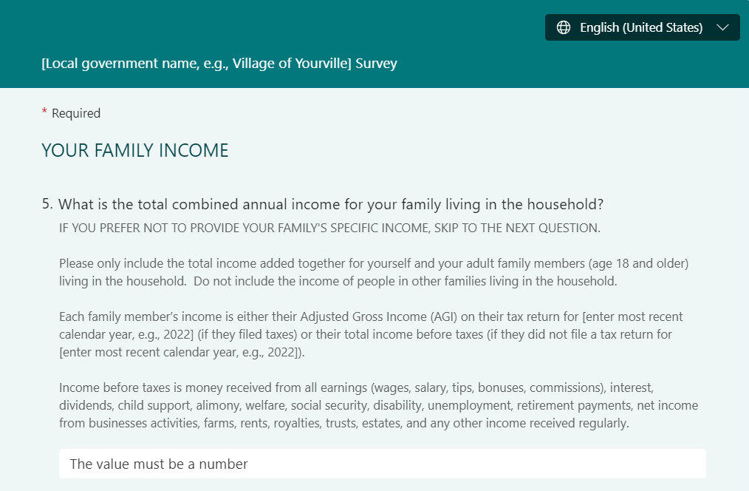

YOUR FAMILY INCOME

Q5. What is the total combined annual income for your family living in the household?

IF YOU PREFER NOT TO PROVIDE YOUR FAMILY'S SPECIFIC INCOME, SKIP TO THE NEXT QUESTION.
Please only include the total income added together for yourself and your adult family members (age 18 and older) living in the household. Do not include the income of people in other families living in the household.
Each family member’s income is either their Adjusted Gross Income (AGI) on their tax return for [enter most recent calendar year, e.g., 2022] (if they filed taxes) or their total income before taxes (if they did not file a tax return for [enter most recent calendar year, e.g., 2022]).
Income before taxes is money received from all earnings (wages, salary, tips, bonuses, commissions), interest, dividends, child support, alimony, welfare, social security, disability, unemployment, retirement payments, net income from businesses activities, farms, rents, royalties, trusts, estates, and any other income received regularly.

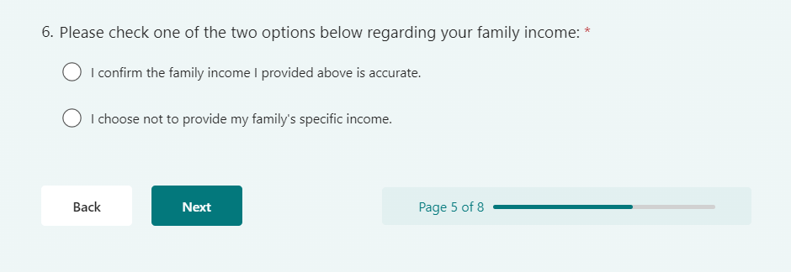

Q6. Please check one of the two options below regarding your family income:

- I confirm the family income I provided above is accurate.
- I choose not to provide my family's specific income.

Branching/Logic Set-Up for the Next Question:
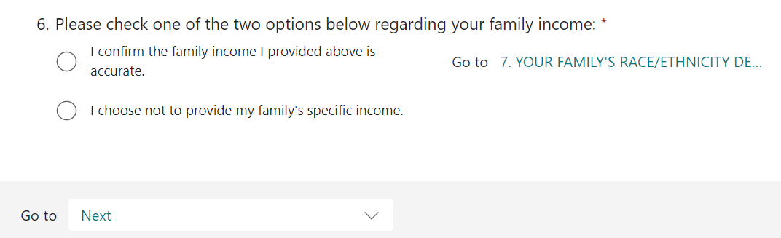

      - If the first option is selected here (indicating the specific family income was provided), then the Race/Ethnicity question will appear next.
      - If the second option is selected here (indicating the specific family income was not provided), then the questions associated with their family size and income level will appear next.
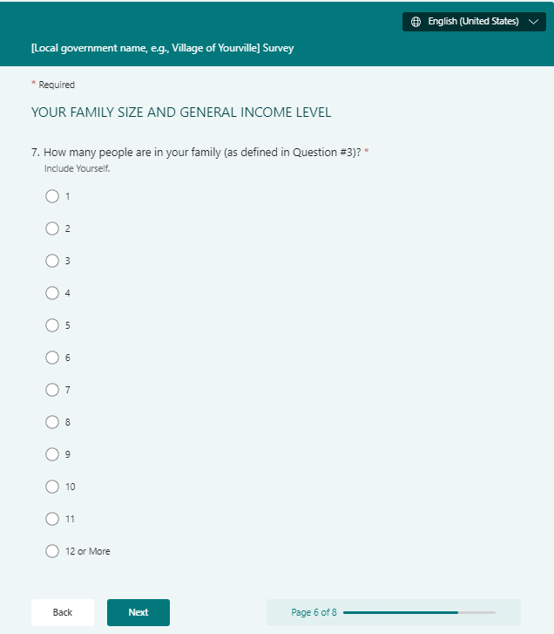

YOUR FAMILY SIZE AND GENERAL INCOME LEVEL

Q7. How many people are in your family (as defined in Question #3)?

Include Yourself.
- 1
- 2
- 3
- 4
- 5
- 6
- 7
- 8
- 9
- 10
- 11
- 12 or More

Branching/Logic Set-Up For Next Question:
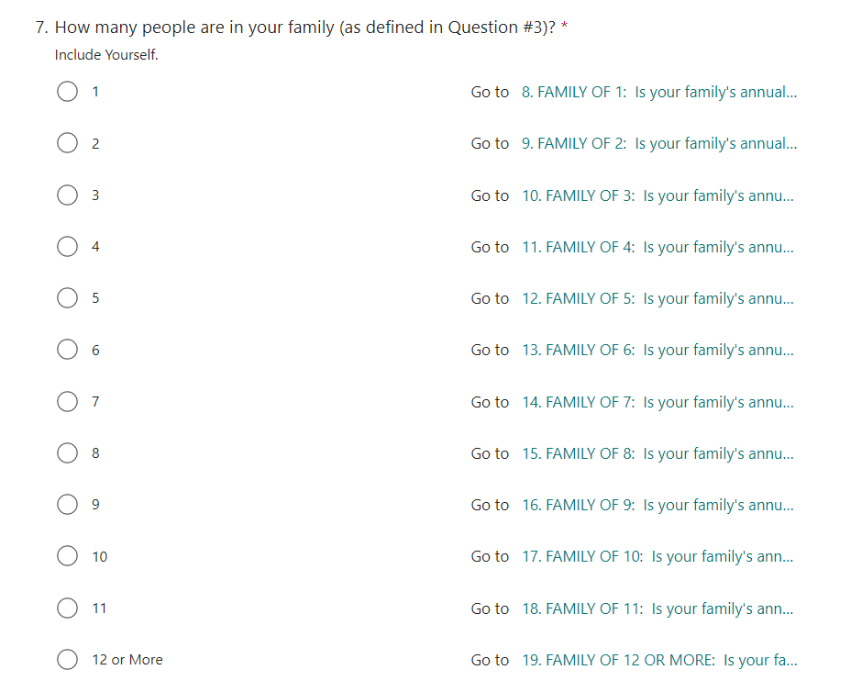
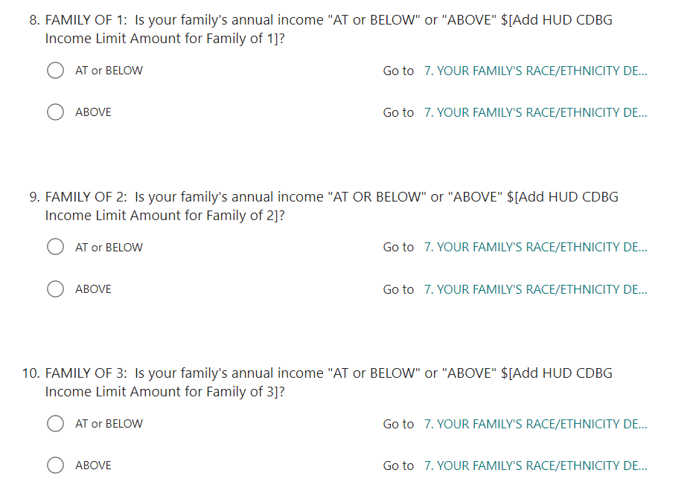
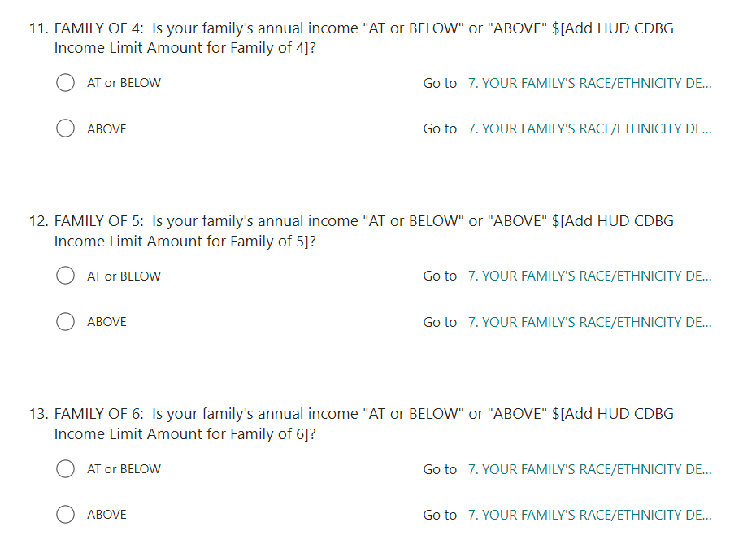

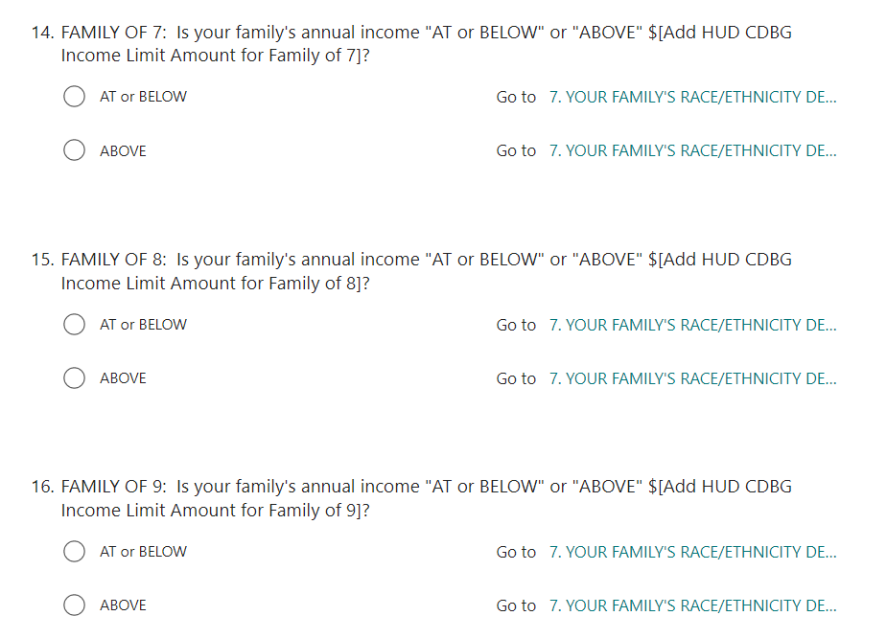
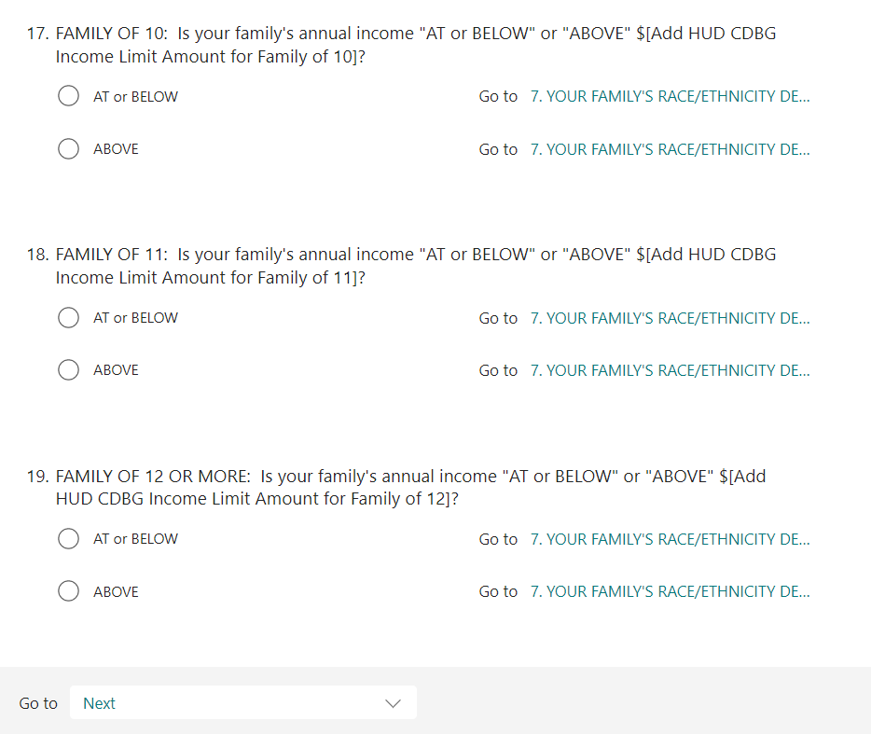

Q8. FAMILY OF 1: Is your family's annual income "AT or BELOW" or "ABOVE" $[Add HUD CDBG Income Limit Amount for Family of 1]?

Please only include only your income Do not include the income of people in other families living in the household.
Income is either your Adjusted Gross Income (AGI) on your tax return for [enter most recent calendar year, e.g., 2022] (if you filed taxes) or your total income before taxes (if you did not file a tax return for [enter most recent calendar year, e.g., 2022]).
Income before taxes is money received from all earnings (wages, salary, tips, bonuses, commissions), interest, dividends, child support, alimony, welfare, social security, disability, unemployment, retirement payments, net income from businesses activities, farms, rents, royalties, trusts, estates, and any other income received regularly.

- AT or BELOW
- ABOVE

Q9. FAMILY OF 2: Is your family's annual income "AT OR BELOW" or "ABOVE" $[Add HUD CDBG Income Limit Amount for Family of 2]?

Please only include the total income added together for yourself and the other family member living in the household only if they are an adult (age 18 or older). Do not include the income of a family member under the age of 18 and people in other families living in the household.
Each family member’s income is either their Adjusted Gross Income (AGI) on their tax return for [enter most recent calendar year, e.g., 2022] (if they filed taxes) or their total income before taxes (if they did not file a tax return for [enter most recent calendar year, e.g., 2022]).
Income before taxes is money received from all earnings (wages, salary, tips, bonuses, commissions), interest, dividends, child support, alimony, welfare, social security, disability, unemployment, retirement payments, net income from businesses activities, farms, rents, royalties, trusts, estates, and any other income received regularly.

- AT or BELOW
- ABOVE

Q10. FAMILY OF 3: Is your family's annual income "AT or BELOW" or "ABOVE" $[Add HUD CDBG Income Limit Amount for Family of 3]?

Please only include the total income added together for yourself and your adult family members (age 18 and older) living in the household. Do not include the income of people in other families living in the household.
Each family member’s income is either their Adjusted Gross Income (AGI) on their tax return for [enter most recent calendar year, e.g., 2022] (if they filed taxes) or their total income before taxes (if they did not file a tax return for [enter most recent calendar year, e.g., 2022]).
Income before taxes is money received from all earnings (wages, salary, tips, bonuses, commissions), interest, dividends, child support, alimony, welfare, social security, disability, unemployment, retirement payments, net income from businesses activities, farms, rents, royalties, trusts, estates, and any other income received regularly.

- AT or BELOW
- ABOVE

Q11. FAMILY OF 4: Is your family's annual income "AT or BELOW" or "ABOVE" $[Add HUD CDBG Income Limit Amount for Family of 4]?

Please only include the total income added together for yourself and your adult family members (age 18 and older) living in the household. Do not include the income of people in other families living in the household.
Each family member’s income is either their Adjusted Gross Income (AGI) on their tax return for [enter most recent calendar year, e.g., 2022] (if they filed taxes) or their total income before taxes (if they did not file a tax return for [enter most recent calendar year, e.g., 2022]).
Income before taxes is money received from all earnings (wages, salary, tips, bonuses, commissions), interest, dividends, child support, alimony, welfare, social security, disability, unemployment, retirement payments, net income from businesses activities, farms, rents, royalties, trusts, estates, and any other income received regularly.

- AT or BELOW
- ABOVE

Q12. FAMILY OF 5: Is your family's annual income "AT or BELOW" or "ABOVE" $[Add HUD CDBG Income Limit Amount for Family of 5]?

Please only include the total income added together for yourself and your adult family members (age 18 and older) living in the household. Do not include the income of people in other families living in the household.
Each family member’s income is either their Adjusted Gross Income (AGI) on their tax return for [enter most recent calendar year, e.g., 2022] (if they filed taxes) or their total income before taxes (if they did not file a tax return for [enter most recent calendar year, e.g., 2022]).
Income before taxes is money received from all earnings (wages, salary, tips, bonuses, commissions), interest, dividends, child support, alimony, welfare, social security, disability, unemployment, retirement payments, net income from businesses activities, farms, rents, royalties, trusts, estates, and any other income received regularly.

- AT or BELOW
- ABOVE

Q13. FAMILY OF 6: Is your family's annual income "AT or BELOW" or "ABOVE" $[Add HUD CDBG Income Limit Amount for Family of 6]?

Please only include the total income added together for yourself and your adult family members (age 18 and older) living in the household. Do not include the income of people in other families living in the household.
Each family member’s income is either their Adjusted Gross Income (AGI) on their tax return for [enter most recent calendar year, e.g., 2022] (if they filed taxes) or their total income before taxes (if they did not file a tax return for [enter most recent calendar year, e.g., 2022]).
Income before taxes is money received from all earnings (wages, salary, tips, bonuses, commissions), interest, dividends, child support, alimony, welfare, social security, disability, unemployment, retirement payments, net income from businesses activities, farms, rents, royalties, trusts, estates, and any other income received regularly.

- AT or BELOW
- ABOVE

Q14. FAMILY OF 7: Is your family's annual income "AT or BELOW" or "ABOVE" $[Add HUD CDBG Income Limit Amount for Family of 7]?

Please only include the total income added together for yourself and your adult family members (age 18 and older) living in the household. Do not include the income of people in other families living in the household.
Each family member’s income is either their Adjusted Gross Income (AGI) on their tax return for [enter most recent calendar year, e.g., 2022] (if they filed taxes) or their total income before taxes (if they did not file a tax return for [enter most recent calendar year, e.g., 2022]).
Income before taxes is money received from all earnings (wages, salary, tips, bonuses, commissions), interest, dividends, child support, alimony, welfare, social security, disability, unemployment, retirement payments, net income from businesses activities, farms, rents, royalties, trusts, estates, and any other income received regularly.

- AT or BELOW
- ABOVE

Q15. FAMILY OF 8: Is your family's annual income "AT or BELOW" or "ABOVE" $[Add HUD CDBG Income Limit Amount for Family of 8]?

Please only include the total income added together for yourself and your adult family members (age 18 and older) living in the household. Do not include the income of people in other families living in the household.
Each family member’s income is either their Adjusted Gross Income (AGI) on their tax return for [enter most recent calendar year, e.g., 2022] (if they filed taxes) or their total income before taxes (if they did not file a tax return for [enter most recent calendar year, e.g., 2022]).
Income before taxes is money received from all earnings (wages, salary, tips, bonuses, commissions), interest, dividends, child support, alimony, welfare, social security, disability, unemployment, retirement payments, net income from businesses activities, farms, rents, royalties, trusts, estates, and any other income received regularly.

- AT or BELOW
- ABOVE

Q16. FAMILY OF 9: Is your family's annual income "AT or BELOW" or "ABOVE" $[Add HUD CDBG Income Limit Amount for Family of 9]?

Please only include the total income added together for yourself and your adult family members (age 18 and older) living in the household. Do not include the income of people in other families living in the household.
Each family member’s income is either their Adjusted Gross Income (AGI) on their tax return for [enter most recent calendar year, e.g., 2022] (if they filed taxes) or their total income before taxes (if they did not file a tax return for [enter most recent calendar year, e.g., 2022]).
Income before taxes is money received from all earnings (wages, salary, tips, bonuses, commissions), interest, dividends, child support, alimony, welfare, social security, disability, unemployment, retirement payments, net income from businesses activities, farms, rents, royalties, trusts, estates, and any other income received regularly.

- AT or BELOW
- ABOVE

Q17. FAMILY OF 10: Is your family's annual income "AT or BELOW" or "ABOVE" $[Add HUD CDBG Income Limit Amount for Family of 10]?

Please only include the total income added together for yourself and your adult family members (age 18 and older) living in the household. Do not include the income of people in other families living in the household.
Each family member’s income is either their Adjusted Gross Income (AGI) on their tax return for [enter most recent calendar year, e.g., 2022] (if they filed taxes) or their total income before taxes (if they did not file a tax return for [enter most recent calendar year, e.g., 2022]).
Income before taxes is money received from all earnings (wages, salary, tips, bonuses, commissions), interest, dividends, child support, alimony, welfare, social security, disability, unemployment, retirement payments, net income from businesses activities, farms, rents, royalties, trusts, estates, and any other income received regularly.

- AT or BELOW
- ABOVE

Q18. FAMILY OF 11: Is your family's annual income "AT or BELOW" or "ABOVE" $[Add HUD CDBG Income Limit Amount for Family of 11]?

Please only include the total income added together for yourself and your adult family members (age 18 and older) living in the household. Do not include the income of people in other families living in the household.
Each family member’s income is either their Adjusted Gross Income (AGI) on their tax return for [enter most recent calendar year, e.g., 2022] (if they filed taxes) or their total income before taxes (if they did not file a tax return for [enter most recent calendar year, e.g., 2022]).
Income before taxes is money received from all earnings (wages, salary, tips, bonuses, commissions), interest, dividends, child support, alimony, welfare, social security, disability, unemployment, retirement payments, net income from businesses activities, farms, rents, royalties, trusts, estates, and any other income received regularly.

- AT or BELOW
- ABOVE

Q19. FAMILY OF 12 OR MORE: Is your family's annual income "AT or BELOW" or "ABOVE" $[Add HUD CDBG Income Limit Amount for Family of 12]?

Please only include the total income added together for yourself and your adult family members (age 18 and older) living in the household. Do not include the income of people in other families living in the household.
Each family member’s income is either their Adjusted Gross Income (AGI) on their tax return for [enter most recent calendar year, e.g., 2022] (if they filed taxes) or their total income before taxes (if they did not file a tax return for [enter most recent calendar year, e.g., 2022]).
Income before taxes is money received from all earnings (wages, salary, tips, bonuses, commissions), interest, dividends, child support, alimony, welfare, social security, disability, unemployment, retirement payments, net income from businesses activities, farms, rents, royalties, trusts, estates, and any other income received regularly.

- AT or BELOW
- ABOVE

- After the Family Size is entered, the question on Income Level associated with the family size selected will appear next. (Example for Family Size of 4 is shown on the next page.)
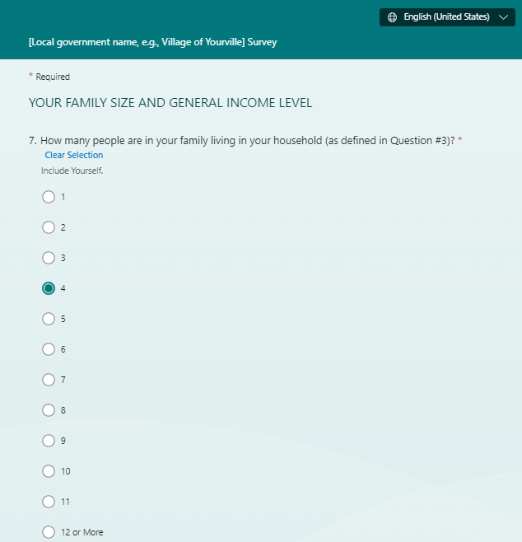

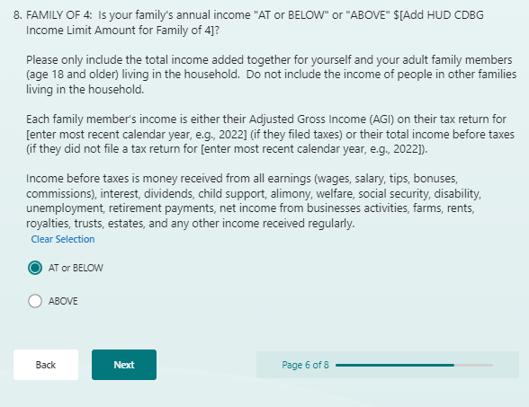

- After the income level response is entered, the Race/Ethnicity section will appear, as shown on the pages that follow.

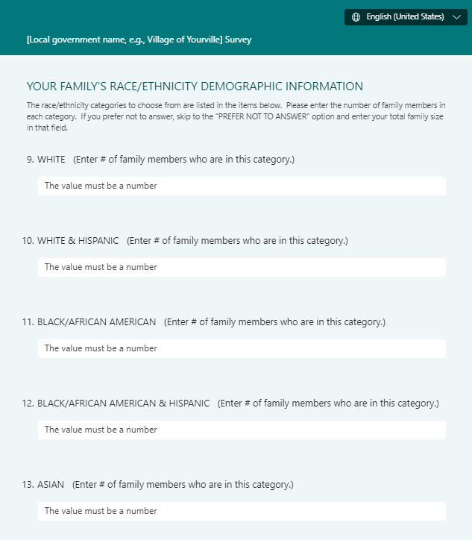
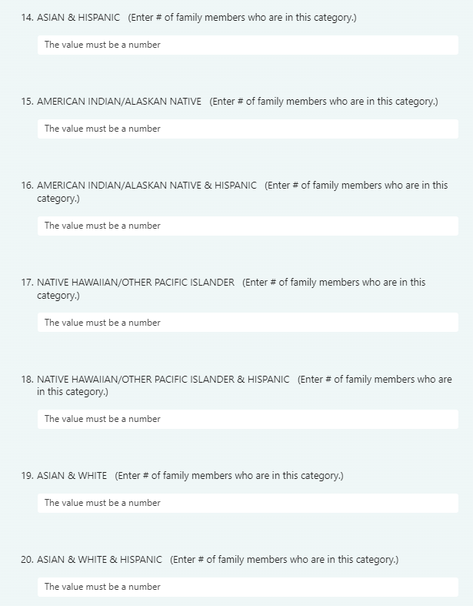
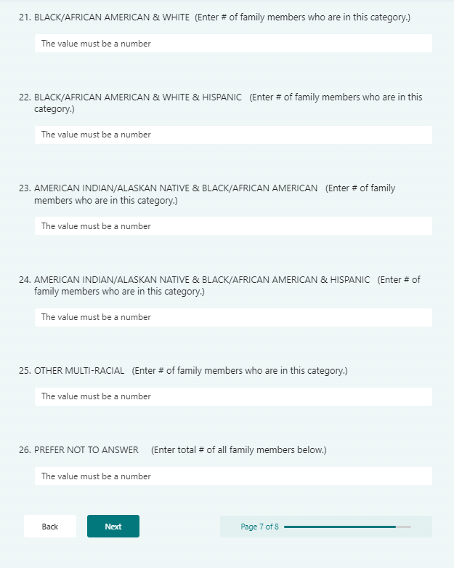

Q20. WHITE (Enter # of family members who are in this category.)

Q21. WHITE & HISPANIC (Enter # of family members who are in this category.)

Q22. BLACK/AFRICAN AMERICAN (Enter # of family members who are in this category.)

Q23. BLACK/AFRICAN AMERICAN & HISPANIC (Enter # of family members who are in this category.)

Q24. ASIAN (Enter # of family members who are in this category.)

Q25. ASIAN & HISPANIC (Enter # of family members who are in this category.)

Q26. AMERICAN INDIAN/ALASKAN NATIVE (Enter # of family members who are in this category.)

Q27. AMERICAN INDIAN/ALASKAN NATIVE & HISPANIC (Enter # of family members who are in this category.)

Q28. NATIVE HAWAIIAN/OTHER PACIFIC ISLANDER (Enter # of family members who are in this category.)

Q29. NATIVE HAWAIIAN/OTHER PACIFIC ISLANDER & HISPANIC (Enter # of family members who are in this category.)

Q30. ASIAN & WHITE (Enter # of family members who are in this category.)

Q31. ASIAN & WHITE & HISPANIC (Enter # of family members who are in this category.)

Q32. BLACK/AFRICAN AMERICAN & WHITE (Enter # of family members who are in this category.)

Q33. BLACK/AFRICAN AMERICAN & WHITE & HISPANIC (Enter # of family members who are in this category.)

Q34. AMERICAN INDIAN/ALASKAN NATIVE & BLACK/AFRICAN AMERICAN (Enter # of family members who are in this category.)

Q35. AMERICAN INDIAN/ALASKAN NATIVE & BLACK/AFRICAN AMERICAN & HISPANIC (Enter # of family members who are in this category.)

Q36. OTHER MULTI-RACIAL (Enter # of family members who are in this category.)

Q37. PREFER NOT TO ANSWER (Enter total # of all family members below.)

YOUR CONTACT INFORMATION

Q38. What is your email address and/or phone number? (OPTIONAL)

We request this so we may contact you if we have any questions about your survey responses. We will not use it for any other purpose.

- After the Race/Ethnicity response is entered, the contact information question will appear next.

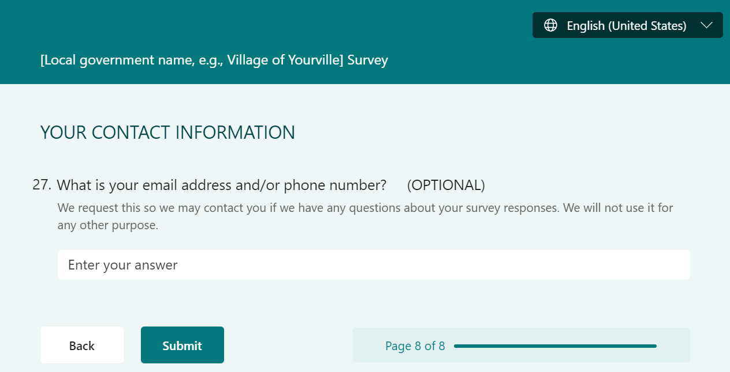

- After the “Submit” button is selected, the final survey screen will appear next.

