CDBG PROJECT SITE SIGN SPECIFICATIONS (TEMPLATE)

The current version of this Attachment is available on the CDBG Implementation Handbook website
(under the “Chapter Attachments/Fillable Forms” section).

The Community Development Block Grant Program (CDBG) project sign (shown in the Template and Example on the next page) is required for all CDBG construction/infrastructure projects, including those involving new construction as well as those involving demolition, rehabilitation, and renovation/expansion. The sign must be erected at or near the site where the construction activities (e.g., new construction, demolition, renovation, expansion)* are occurring, in accordance with the specifications below.

SIGN SPECIFICATIONS:

- Sign dimensions: 4 feet by 8 feet
- The smallest print must be readable from 50 feet away
- Must be on plywood panel APA Rated A-B Grade-Exterior (any alternative material must be pre-approved by DEHCR)
- Must be high quality, professional-grade sign (i.e., paper taped to plywood board is not acceptable)
- Generally, must be erected outdoors and weatherproofed for outdoor posting (an exception to an outdoor location must be pre-approved by DEHCR)
- Sign must include:
  - Current DEHCR and DOA logos (accessed on the CDBG Implementation Handbook website under Chapter 7 Attachments)
  - Name of grantee
  - Title of project
  - Reference to the Community Development Block Grant (CDBG) Program and funding sources [Wisconsin Department of Administration (DOA) and U.S. Department of Housing and Urban Development (HUD)], as shown in the template and example on the next page
  - Name and title of the current Governor of the State of Wisconsin and the current Secretary of the Department of Administration (check the DOA website for updates prior to printing sign)
  - Name and title of the grantee’s chief elected official
- Must be on White background
- The following text must be in RED font:

A COMMUNITY FACILITIES PARTNERSHIP
FINANCED IN PART BY THE COMMUNITY DEVELOPMENT BLOCK GRANT FROM THE
WISCONSIN DEPARTMENT OF ADMINISTRATION AND THE
U.S. DEPARTMENT OF HOUSING AND URBAN DEVELOPMENT

- All other text on the sign must be in BLACK font

*Generally, one sign is required per project. If the project involves multiple phases, more than one sign may be needed to ensure a CDBG project sign remains posted for each phase of the project. If a project involves construction at multiple locations, the CDBG project sign should be erected at the site in the highest traffic area where the most residents are likely to see it, or at a central location between all of the construction sites (in a high-traffic area when practical). All project locations should be listed as part of the Project Title on the sign when practical.
CDBG PROJECT SITE SIGN TEMPLATE & EXAMPLE

The current version of this Attachment is within the Attachment 7-T available on the CDBG Implementation Handbook website (under the “Chapter Attachments/Fillable Forms” section).

Community Name (e.g., Village of Yourville)
Project Type (e.g., Street and Utility Improvements Project: Main Street & 2nd Avenue, or New Community Center Construction, or New Senior Center Construction)
A COMMUNITY FACILITIES PARTNERSHIP
FINANCED IN PART BY THE COMMUNITY DEVELOPMENT BLOCK GRANT FROM THE
WISCONSIN DEPARTMENT OF ADMINISTRATION AND THE
U.S. DEPARTMENT OF HOUSING AND URBAN DEVELOPMENT
Tony Evers, Governor

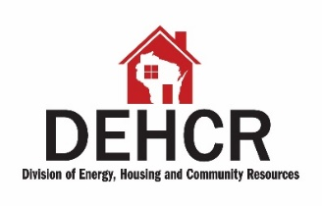
Kathy Blumenfeld, Secretary
CEO’s Name & Title (i.e., Mayor, Town Chair, etc.)
State and Federal Equal Opportunity laws apply in the construction and use of this project.

Village of Yourville
Street & Utility Improvements Project:
Main Street, 2nd Avenue, & Miller Road
A COMMUNITY FACILITIES PARTNERSHIP
FINANCED IN PART BY THE COMMUNITY DEVELOPMENT BLOCK GRANT FROM THE
WISCONSIN DEPARTMENT OF ADMINISTRATION AND THE
U.S. DEPARTMENT OF HOUSING AND URBAN DEVELOPMENT
Tony Evers, Governor
Kathy Blumenfeld, Secretary
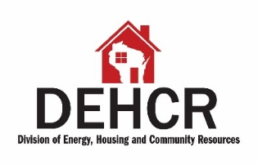

Jane Smith, Village President
State and Federal Equal Opportunity laws apply in the construction and use of this project.

