GRANTEE/UGLG NAME:
DEHCR GRANT AGREEMENT #:

PRE-CONSTRUCTION CHECKLIST FOR CONTRACTORS

MEETING LABOR STANDARDS CONTRACT REQUIREMENTS
INTRODUCTION:
The following checklist has been prepared to assist contractors and sub-contractors in meeting contractual labor standards responsibilities. All major administrative and procedural activities have been covered in the sequence they will occur as the construction project proceeds. Careful attention to and the use of this checklist should result in a minimum number of problems with respect to labor standards.
EXPLANATORY NOTES:
The word “recipient” as used below refers to the entity (e.g., the Unit of General Local Government [UGLG]) that was awarded the federal grant funds. The word "employer" as used below refers to the project contractor, each sub-contractor, or each lower-tier sub-contractor. Payrolls and other documentary evidence of compliance are required to be sent to the recipient for review (all to be submitted through the project contractor). The delivery procedure is as follows:
      - Each lower-tier sub-contractor, after careful review, submits the required documents to the respective sub-contractor.
      - Each sub-contractor, after checking their own and those of each lower-tier sub-contractor (if applicable), submits the required documents to the contractor.
3. The contractor, after reviewing all payrolls and other documentation, including their own, and correcting violations where necessary, submits payrolls to the recipient.
All employers should check each of the following statements as being true. If any statement is not true, the contractor or his representative should contact the recipient for special guidance.

EMPLOYER PRE-CONSTRUCTION CHECKLIST & ACKNOWLEDGEMENT
Complete the information below for numbers 1 through 6, sign this sheet, keep a copy for file records, and submit the original to the designated project supervisor. This should be done 21 days before the work begins.
BEFORE CONSTRUCTION BEGINS THE EMPLOYER HAS:

- Not been debarred or otherwise made ineligible to participate in any federally-assisted project. | ☐
- Received appropriate contract provisions covering labor standards requirements. | ☐
- Reviewed and understands all labor standards contract provisions. | ☐
- Received the applicable Wage Decision(s) as part of the contract. | ☐
- Requested from the recipient through the Additional Classification request process and received the minimum required wage rate (hourly wage plus fringe benefits value) for any classification to be worked that is not included on the applicable Wage Decision(s) for the project. | ☐
- Requested and received certification from the state Bureau of Apprenticeship and Training (recognized by USBAT) for any apprentice and/or trainee program in which the employer participates, and submitted a copy thereof to the recipient prior to the apprentice(s)/trainee(s) working on the project. | ☐

(Contractor Signature) | (Title) |  | (Date)
(Location of Project: City, County, State) |  |  | (Contract Number)

COMPLIANCE AT CONSTRUCTION START - CONFIRM THE CONTRACTOR HAS:

- Notified sub-contract award recipient of construction start date in writing. | ☐
- Placed each of the following on a bulletin board prominently located on the project site which can be seen easily by the workers (and replaced if lost or unreadable any time during construction): | ☐
- Applicable Wage Decision(s) | ☐
- Notice to Employees (WH 1321)  English: https://www.dol.gov/whd/regs/compliance/posters/fedprojc.pdf  Spanish: https://www.dol.gov/whd/regs/compliance/posters/davispan.pdf | ☐
- Before assigning each project worker to work, obtained worker's full name and has assigned each employee an individual identification (i.d.) number (for payroll purposes). | ☐
- Obtained a copy of each apprentice's certificate with the apprentice's registration number and number of years of apprenticeship from the state Bureau of Apprenticeship and Training (BAT). | ☐
- Informed each worker of:
- Their work classification (journeymen or job title) as it will appear on the certified payroll record, and as determined from the applicable Wage Decision or through the Additional Classification process. | ☐
- Their duties of work. | ☐
- The U.S. Department of Labor’s (USDOL's) requirement on this project that the employee is designated as being a journeyman, an apprentice, or a laborer. | ☐
- If journeymen, is to be paid the journeyman's minimum required wage rate (as specified on the applicable Wage Decision) or more; | ☐
- If apprentice, is to be paid not less than the apprentice's rate for the trade based on their year of apprenticeship; or | ☐
- If laborer, is to do laborer's work only--not use any tool or tools of the trade--and not perform any part of a journeyman's work--and is to be paid the laborer's minimum required wage rate (as specified on the applicable Wage Decision) or more. | ☐
- Understands the requirements each laborer or mechanic who performs work on the project in more than one classification within the same work week shall be classified and paid at the highest wage rate applicable to any of the work which the employee performs unless the following requirements are met:
- Accurate daily time records shall be maintained. These records must show the time worked in each classification and the rate of pay for each classification. | ☐
- The payroll shall show the hours worked in each classification and the wage rate paid for each classification.  - Section 3 Compliance Note: The reporting of employees’ and contractors’ Section 3 status when reporting employee work on the HUD funded/CDBG project is required to meet the Section 3 requirements for HUD projects. Refer to the “Section 3 Contract Requirements” language in the employer’s contract for the project for guidance in determining employees’ and employers’ Section 3 status. The criteria and nature of reporting differs depending on whether the recipient was awarded the HUD funds prior to 11/30/2020, or on or after 11/30/2020. | ☐
- Has informed each worker of their hourly wage rate and the minimum required wage rate (as specified on the applicable Wage Decision) for their work, including: | ☐
- Time and one-half for all work over 40 hours in any work week (see Contract Work Hours and Safety Standards Act (CWHSSA)). | ☐
- Fringe benefits, if any (see applicable Wage Decision). | ☐
- Deductions from their pay. | ☐
- Has informed each worker that they will be subject to being interviewed on the job by the recipient or a HUD, USDOL, or other U.S. government inspector, to confirm that their employer is complying with all labor requirements. | ☐
- Has informed each journeyman and each apprentice that a journeyman must be on the job at all times when an apprentice is working and verifying the ratio of journeyman to apprentice through the indenture papers. | ☐

COMPLIANCE DURING CONSTRUCTION – CONFIRM THE CONTRACTOR HAS:

- Not selected, assigned, paid different pay rates to, transferred, upgraded, demoted, laid off, or dismissed any project worker because of race, color, religion, sex, or national origin. | ☐
- Employed all registered apprentices referred to the employer through normal channels up to the applicable ratio of apprentices to journeymen in each trade used by the employer. | ☐
- Maintained basic employment records accessible to inspection by the recipient or U.S. government representatives. | ☐
- Complied with all health and safety standards. | ☐
- Paid all workers weekly. | ☐
- Submitted weekly certified payroll records that include the required information and documentation. | ☐
- The weekly payroll records are prepared on the recommended Wisconsin Department of Transportation (WisDoT) Weekly Payroll Report form (WisDoT Form 1926) (a Microsoft Excel document that may be modified/customized for the specific project and includes formulas for automatically calculating data and entering details of job classifications, apprenticeship status, and types of fringe benefits and deductions) and Compliance Statement form (WisDoT Form 1816); or comparable forms that allows for reporting the same details.  The U.S. Department of Labor Weekly Payroll Record Form WH-347 or an internal payroll system reporting form that allows for reporting the same information is acceptable. Note that when using Form WH-347, the details of the types of fringe benefits and deductions and value of each fringe benefit and deduction must be itemized for each employee on the Statement of Compliance page of Form WH-347 or attached to the payroll record. | ☐
Wisconsin Department of Transportation (WisDoT) Weekly Payroll Report form (WisDoT Form 1926), Information Sheet (instructions) & Compliance Statement (WisDoT Form 1816):
https://wisconsindot.gov/pages/doing-bus/civil-rights/labornwage/payroll-submission-compliance.aspx
Refer to the “Paper-based payrolls (emergency projects) section:

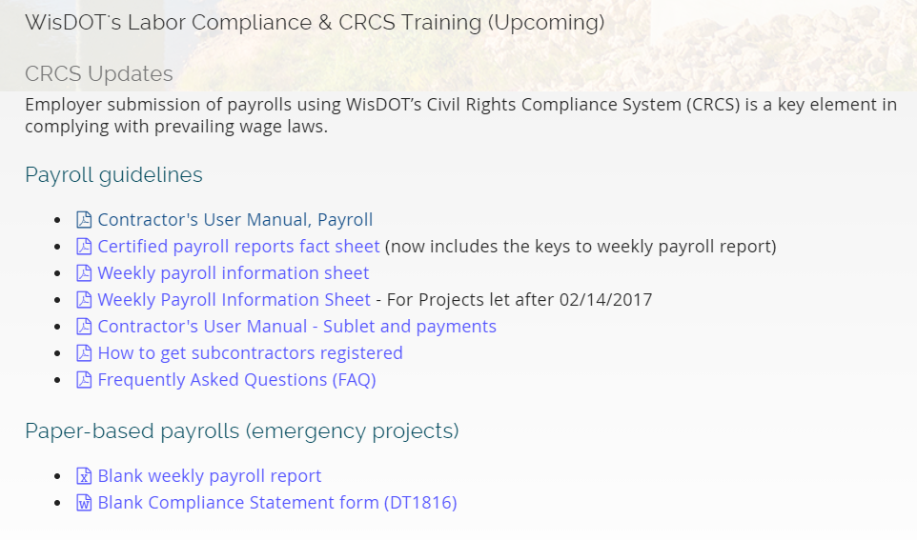

U.S. Department of Labor (USDOL) Payroll Record Form (includes a Statement of Compliance page) & Instructions:
WH347 Form & Instructions: http://www.dol.gov/whd/forms/wh347instr.htm
(Direct link to WH347 also here: http://www.dol.gov/whd/forms/wh347.pdf)
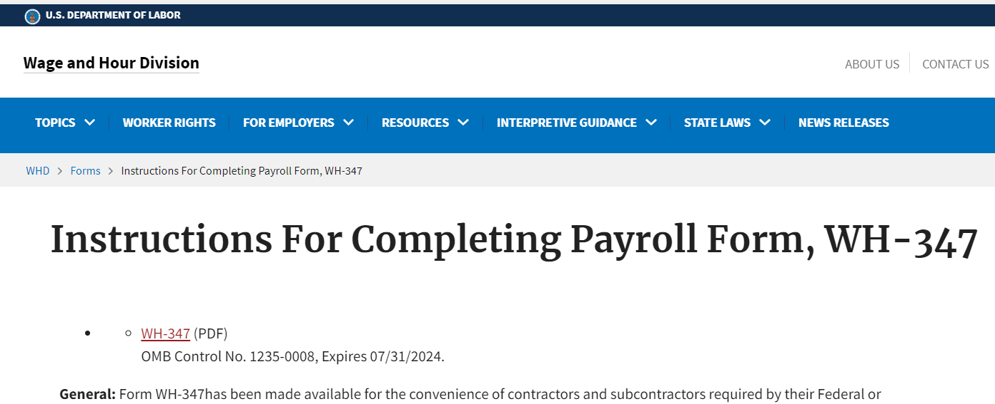
The recipient does not need to review those project workers listed on the payroll who perform work which is descriptive of any of the following job titles which are exempt from labor requirements: project superintendent, project engineer, messenger, clerical workers, timekeepers, bookkeepers, payroll clerks, and Supervisory foreman (less than 20% of time as a working foreman).

Any alternate payroll form used should be cleared with the recipient’s Labor Standards Officer (LSO) before the employer starts work on the project. A project printout from the employer’s internal payroll software system, for example, is acceptable provided that all data shown and required on the WisDoT payroll form and Compliance Statement form, or on the front and back of the USDOL payroll record Form WH-347, is on or included with the payroll submitted to employer.
- The weekly payroll records include the required information and comply with the following:

- Name of Contractor or Subcontractor. Includes name of employer, showing whether contractor or sub-contractor. |  |  |  |  | ☐
- Address. Includes address of employer. |  |  |  |  | ☐
- Payroll Number. Each weekly payroll is numbered in sequential order (starting with Payroll No. "1" for the employer’s first work week on the project). |  |  |  |  | ☐
 | - If employer's workers perform no physical work on the project during work week, the employee has submitted a "no work" certified payroll record, letter or email for that work week. |  |  |  | ☐
 | - Payroll of employer's final work week on the project (completion of his work) is marked "Final." |  |  |  | ☐
- For Week Ending. Is dated with last date of the work week specified. |  |  |  |  | ☐
- Project and Location. Includes name of project and city in which the project is located. |  |  |  |  | ☐
- Project or Contract Number. Includes the contract number provided by the recipient. |  |  |  |  | ☐
- Name and Individual Identifying Number of Worker. Includes the names and identification numbers of employees, as they appear on the employee’s paycheck (e.g., the last four digits of the Social Security number or other unique i.d. number). |  |  |  |  | ☐
- Number of Withholding Exemptions. May be included for employer's convenience - it is not required by HUD to be completed. |  |  |  |  | ☐
- Work Classification (job title). Must be listed for the worker as included in the Wage Decision and denotes the work that worker actually performed. If the job title corresponds to a job classification with multiple group numbers in the Wage Decision, then provide a detailed job title and group number (e.g., Backhoe Operator =/+ 130,000 lbs [Group #3]) versus only listing “Operator.” |  |  |  |  | ☐
 |  | Note: If the applicable classification is not included in the Wage Decision, the contractor should contact the recipient immediately, and request the classification through the Additional Classification request process.
- Apprentice. If worker is an apprentice, their state BAT registration number and year of apprenticeship is included in on payroll record, the first time the apprentice's name appears on the payroll. |  |  |  |  | ☐
- Split Classification. If worker has performed work in more than one classification of work during the work week, such as carpenter and laborer, the division of work will be shown on separate lines of the payroll. |  |  |  |  | ☐
- Accurate daily time records show the exact hours of work performed daily in each class of work. |  |  |  |  | ☐
- Each class of work the employee performed is listed. |  |  |  |  | ☐
- The employee’s name is repeated when listing additional classifications worked. |  |  |  |  | ☐
- The breakdown of hours worked daily under each work classification is stated. |  |  |  |  | ☐
- The applicable wage rate (which must be the minimum required wage rate, as specified on the applicable Wage Decision, or more) for each classification of work is stated. |  |  |  |  | ☐
- If the above is not done, the worker is paid at least the highest minimum required wage rate (as specified on the applicable Wage Decision) of all classes of work performed for all hours worked. |  |  |  |  | ☐
Average Pay of Two Classes of Work Not Accepted. The employer shall not pay a "semi-journeyman" or semi-skilled laborer the average of journeyman's and laborer's rates. The actual hours each worker uses tools of trade (journeyman) and each hour the employee does not use tools of the trade (laborer) must be recorded separately on the payroll.

Helper. The work classification of "helper" is not accepted by the Department of Housing and Urban Development (HUD) unless included in the applicable Wage Decision issued by the Secretary of Labor/USDOL for the project. Any employee listed as "helper" in absence of such classification in the Wage Decision must be paid the journeyman's wage rate for hours the employee uses tools of the trade.
- Rate of Pay. Cannot be less than the minimum required wage rate for the work classification (as specified in the applicable Wage Decision). |  |  |  |  | ☐
 | The Overtime Rate of Pay is not less than one and one-half times the worker's basic (straight) hourly rate of pay (Contract Work Hours Safety Standards Act). Overtime rate is not paid on fringes. |  |  |  |  | ☐
- Apprentices. Apprentice status verified. If a copy of the apprentice's registration certificate from the State BAT has not been submitted to recipient by employer (through contractor), the apprentice must be paid journeyman's rate. |  |  |  |  | ☐
- Piece Worker. Wage must be stated in at an hourly rate, the gross pay for the work week (work on the project) divided by the total number of hours worked on the project during the work week. |  |  |  |  | ☐
- Gross Amount Earned. Must equal straight hours shown multiplied by straight rate of pay shown, plus overtime hours (if any) shown multiplied by overtime rate of pay shown. |  |  |  |  | ☐
- Deductions. Each deduction must be shown on the payroll record. Allowable deductions are only those made that are required by law or voluntarily authorized by the worker in writing before the work week began, or through provision in a bargaining agreement to be deducted from the respective worker's pay. |  |  |  |  | ☐
- Net Wages stated are (gross wages minus deductions) are shown. |  |  |  |  | ☐
- Section 3 Status: See “Section 3 Compliance Note” (item #6 on page 3 of this document).
- Statement of Compliance. Each employer has:

- Completed and signed a statement of compliance, using the copy of the WisDoT Compliance Statement form or the Statement of Compliance page within USDOL Form WH347, or similar form; and understands the penalties for falsification. |  | ☐
- Indicated on the statement of compliance if fringe benefits are included in the Wage Decision for any of the workers. |  | ☐
 | 2(a). if fringe benefits are paid to approved fund(s), or | ☐
 | 2(b). if paid directly to each affected worker--included in paycheck for the work week – the employee’s paycheck representing at least the minimum required rate of hourly wage plus fringe benefits amount (as specified in the applicable Wage Decision). | ☐
- Signed the statement of compliance and entered the name and title of the signatory entered. |  | ☐
- Has the person who signs the payroll be the employer or an official of the employer who is legally authorized to act for the employer. |  | ☐

- Weekly Payroll Review. Each employer has promptly:

- Reviewed the weekly payroll for compliance with all labor requirements (using this check list) and made necessary corrections. | ☐
- Each Lower-Tier Sub-contractor has submitted their weekly payroll or "no work" certified payroll record, letter or email to the respective sub-contractor, which shall be received within three (3) calendar days from the last date of the work week. | ☐
- Each sub-contractor has received a payroll or "no work" certified payroll record, letter or email from each of their lower-tier sub-contractors, reviewed each and their own payroll, made necessary corrections, and submitted all such payrolls to the contractor, which shall be received within five (5) calendar days from the last date of the work week. | ☐
- Contractor has received a payroll or "no work" certified payroll record, letter or email from each sub-contractor and each lower-tier sub-contractor monitored each including their own payroll, made necessary corrections, and collectively submitted them to the recipient within seven (7) working days of the last date of the respective work week. | ☐

Payrolls and other documentary evidence of compliance are required to be sent to the UGLG’s Labor Standards Officer (LSO) for review (all to be submitted through the project contractor).

