SAMPLE
(Detailed Itemization of Project Costs)

CITY OF YOURTOWN
2024 WATER TOWER PROJECT
DETAILED ESTIMATE OF PROBABLE COSTS
(CITY OF YOURTOWN, YOURVILLE COUNTY, WISCONSIN)

ASSUMPTIONS:
- 500 GALLON SPHEROID ELEVATED STORAGE TANK
- LOCATED IN SW QUADRANT OF INTERSECTION OF MAIN STREET AND WISCONSIN DRIVE (SITE 1)
- CONNECT T0 10” WATERMAIN ON MAIN STREET
- EXTEND STORM SEWER FOR OVERFLOW DRAIN
- GRAVEL DRIVEWAY WITH CONCREATE APRON AT WISCONSIN DRIVE
- MODERATE FOUNDATION REQUIRED (CONFIRM WITH GEOTECHNICAL EXPLORATION)
- NO SCADA, MIXER, SIREN, ANTENNA, INTERIOR CONDITIONED SHELTER
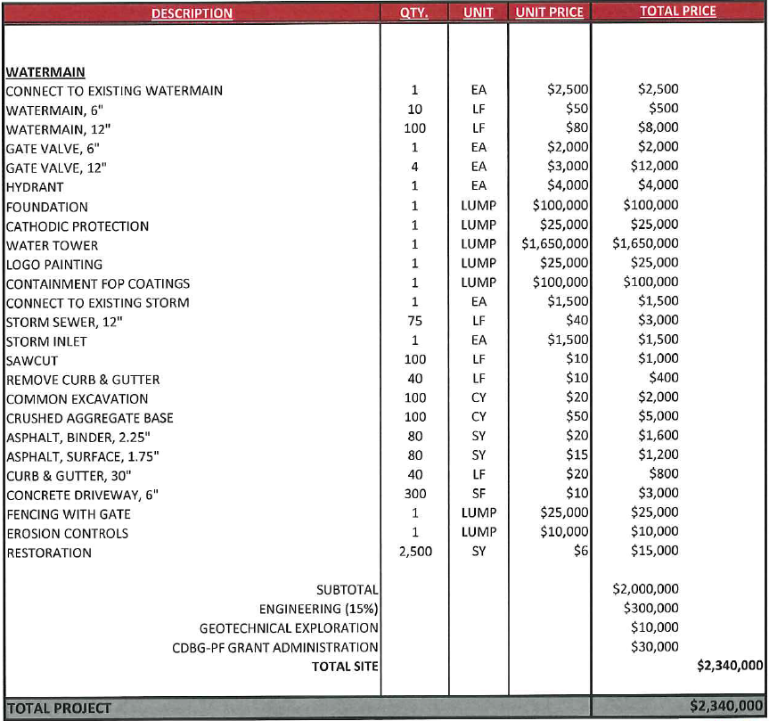
ABC123 ENGINEERING COMPANY
03/31/2024

